**INTRO TO JAVA 1 Shriya Garg**

**Q1. Write a program to replace a substring inside a string with other string ?**

**package dayfirst;**

**public class SubstrReplace {**

**public static void main(String args[]) {**

**String str="Shriya is here.";**

**System.*out*.println("Initial String : "+str);**

**System.*out*.println( "\nReplaced String : "+str.replace( "is", "was" ) );**

**}**

**}**

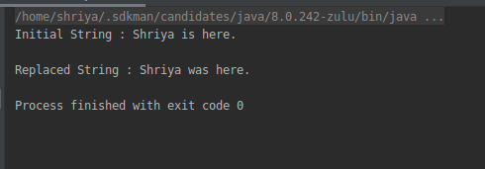

**Q2. Write a program to find the number of occurrences of the duplicate words in a string and print them ?**

**package dayfirst;**

**public class CountDuplicate {**

**public static void main(String[] args) {**

**String input = "Hi hello black blue hElLO blue Blue ";**

**input = input.toLowerCase();**

**String[] words = input.split(" ");**

**int wcount=1;**

**for (int i=0; i<words.length; i++){**

**for(int j=i+1; j<words.length; j++){**

**if (words[i].equals(words[j])){**

**wcount+=1;**

**words[j]="0";**

**}**

**}**

**if (words[i]!="0" && wcount>1) System.*out*.println(words[i]+ " : "+ wcount);**

**wcount=1;**

**}**

**}**

**}**

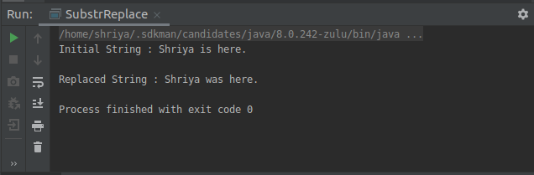

**Q3. Write a program to find the number of occurrences of a character in a string without using loop?**

**package dayfirst;**

**public class CountOccurence {**

**public static void main(String[] args) {**

**String str = "Java is an OOP language";**

**String recStr = "a"; //Recurring string**

**int count = str.length() - str.replace(recStr, "").length();**

**System.*out*.println("Number of occurrence of 'a' in String \n'"+str+"' = "+ count);**

**}**

**}**

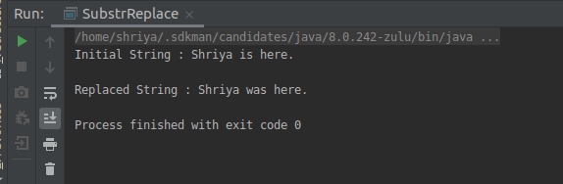

**Q4. Calculate the number & Percentage Of Lowercase Letters,Uppercase Letters, Digits And Other Special Characters In A String**

**package dayfirst;**

**public class StringPercentage {**

**public static void main(String[] args) {**

**String str = "shriyaGarg.123@gmail.com";**

**int count = 0, upperCase=0, lowerCase=0, digits=0, specialChar=0;**

**float ucase_p, lcase_p, dig_p, spchar_p;**

**count = str.length();**

**for (int i=0; i<count; i++){**

**if (Character.*isUpperCase*(str.charAt(i)))**

**upperCase++;**

**else if (Character.*isLowerCase*(str.charAt(i)))**

**lowerCase++;**

**else if (Character.*isDigit*(str.charAt(i)))**

**digits++;**

**else**

**specialChar++;**

**}**

**ucase_p = (float)upperCase/(float)count *100;**

**lcase_p = (float)lowerCase/(float)count *100;**

**dig_p = (float) digits/ (float)count *100;**

**spchar_p= (float)specialChar/ (float)count *100;**

**System.*out*.println("Total characters in String '"+str+"' = " + count);**

**System.*out*.println("No. of Uppercase letters: " + upperCase + " and % = " +**

**ucase_p);**

**System.*out*.println("No. of lowercase letters: " + lowerCase + " and % = " +**

**lcase_p);**

**System.*out*.println("No. of digits: " + digits + " and % = " + dig_p);**

**System.*out*.println("No. of special letters: " + specialChar + " and % = " +**

**spchar_p);**

**}**

**}**

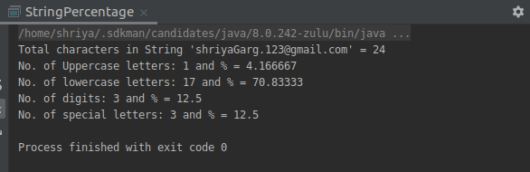

**Q5. Find common elements between two arrays.**

**package dayfirst;**

**import java.util.*;**

**public class CommonArray {**

**public static void main(String args[]) {**

**int[] arr1 = {1, 7, 3, 9, 2};**

**int[] arr2 = {3, 2, 12, 9, 40, 32, 4};**

**System.*out*.println("Array1 = "+ Arrays.*toString*(arr1) + "\nArray2 : "+ Arrays.*toString*(arr2));**

**System.*out*.println("\nCommon elements of both arrays : ");**

**for (int i = 0; i < arr1.length; i++) {**

**for (int j = 0; j < arr2.length; j++) {**

**if (arr1[i] == arr2[j]) {**

**System.*out*.println(arr1[i]);**

**}**

**}**

**}**

**}**

**}**

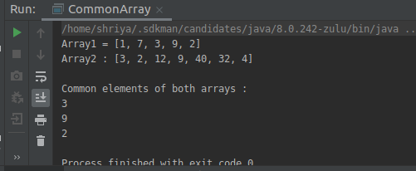

**Q6. There is an array with every element repeated twice except one. Find that element**

**package dayfirst;**

**import java.util.Arrays;**

**public class RepeatedTwice {**

**public static void main(String[] args) {**

**int[] arr1 = {1,2,3,4,5,6,7,8,9,1,2,3,4,6,7,8,9};**

**int count=0;**

**for (int i=0; i < arr1.length; i++) {**

**count=0;**

**for (int j = 0; j < arr1.length; j++) {**

**if (arr1[i] == arr1[j]) {**

**count++;**

**}**

**}**

**if (count != 2)**

**System.*out*.println("Element that is not present exactly two times in array \n "+ Arrays.*toString*(arr1) + "\n is "+arr1[i]);**

**}**

**}**

**}**

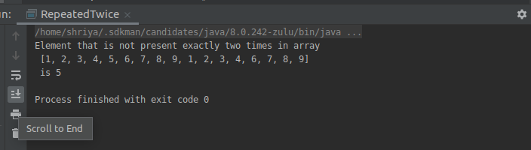

**Q7. Write a program to print your Firstname,LastName & age using static block,static method & static variable respectively**

**package dayfirst;**

**public class StaticExplore {**

**static String *fname*;**

**static String *lname*;**

**static int *age*;**

**static{**

***fname*= "Shriya";**

***lname*= "Garg";**

***age* = 21;**

**System.*out*.println("STATIC BLOCK is called");**

**}**

**static void showData(){**

**System.*out*.println("STATIC METHOD is called");**

**System.*out*.println(*lname*);**

**}**

**public static void main(String[] args) {**

**System.*out*.println(StaticExplore.*fname*);**

***showData*();**

**System.*out*.println("STATIC VARIABLES is called\n"+*age*);**

**}**

**}**

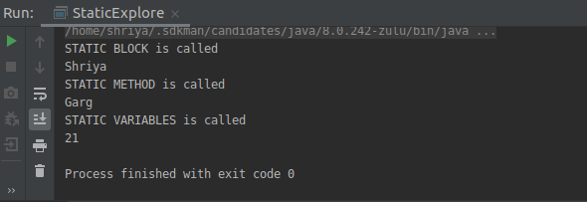

**Q8. Write a program to reverse a string and remove character from index 4 to index 9 from the reversed string using String Buffer**

**package dayfirst;**

**public class BufferRev {**

**public static void main(String[] args) {**

**StringBuffer strBuff = new StringBuffer("This is Shriya");**

**System.*out*.println("Original String : "+ strBuff);**

**strBuff.reverse();**

**System.*out*.println("Reverse String : "+strBuff);**

**strBuff.replace(4,9,"");**

**System.*out*.println("Editted String : "+strBuff);**

**}**

**}**

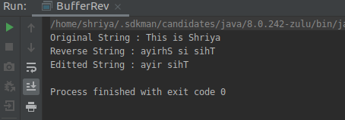

**Q9.Write a program to display values of enums using a constructor & getPrice() method (Example display house & their prices)**

**package dayfirst;**

**enum Houses {**

***Delhi*(6000000), *Noida*(4000000), *Gurgaon*(7000000);**

**private int hprice;**

**Houses(int price){**

**hprice=price;**

**}**

**int getPrice(){**

**return hprice;**

**}**

**}**

**public class House{**

**public static void main(String[] args) {**

**System.*out*.println("Hosuing List : ");**

**for (Houses p: Houses.*values*()) System.*out*.println(**

**p+ "'s "+"Housing price is : Rs."+ p.getPrice() );**

**}**

**}**

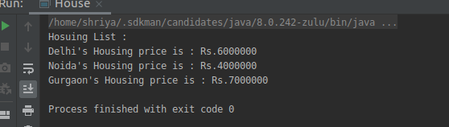

**Q10.Write a single program for following operation using overloading**

**A) Adding 2 integer number**

**B) Adding 2 double**

**C) Multiplying 2 float**

**D) Multiplying 2 int**

**E) Concate 2 string**

**F) Concate 3 String**

**package dayfirst;**

**import com.sun.xml.internal.ws.api.model.wsdl.WSDLOutput;**

**import java.sql.SQLOutput;**

**public class OverloadingOps {**

**int add(int num1, int num2){**

**return num1+num2;**

**}**

**double add( double num1, double num2){**

**return num1+num2;**

**}**

**int mul(int num1, int num2){**

**return num1*num2;**

**}**

**double mul( double num1, double num2){**

**return num1*num2;**

**}**

**String concat(String s1, String s2){**

**return s1+s2;**

**}**

**String concat(String s1, String s2, String s3){**

**return s1+s2+s3;**

**}**

**public static void main(String[] args){**

**OverloadingOps obj = new OverloadingOps();**

**/* This time promotion won't happen as there is**

**\* a method with arg list as (int, float)**

**\*/**

**System.*out*.println("Function Add");**

**System.*out*.println(obj.add(10, 20));**

**System.*out*.println(obj.add(10.0, 20.67));**

**System.*out*.println("\nFunction Multiply");**

**System.*out*.println(obj.mul(10, 20));**

**System.*out*.println(obj.mul(10.0, 20.67));**

**System.*out*.println("\nFunction Concat");**

**System.*out*.println(obj.concat("One", "Two"));**

**System.*out*.println(obj.concat("One", "Two","Three"));**

**}**

**}**

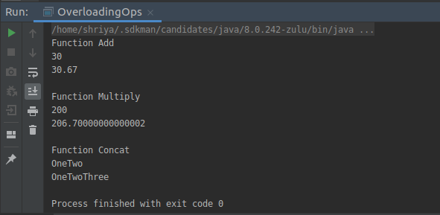

**Q11.Create 3 sub class of bank SBI,BOI,ICICI all 4 should have method called getDetails which provide there specific details like rateofinterest etc,print details of every banks**

**package dayfirst;**

**public class Bank {**

**protected String Bname;**

**protected int Roi;**

**public Bank(){**

**Bname = "Default";**

**Roi= 0;**

**}**

**public void getDetails(){**

**System.*out*.println("Bank Name: " + Bname);**

**System.*out*.println("Rate of Interest: "+ Roi);**

**}**

**}**

**class SBI extends Bank {**

**public SBI() {**

**Bname = "SBI";**

**Roi = 6;**

**}**

**public void getDetails() {**

**System.*out*.println("");**

**System.*out*.println("Bank Name: " + Bname);**

**System.*out*.println("Rate of Interest: " + Roi);**

**}**

**}**

**class BOI extends Bank {**

**public BOI() {**

**Bname = "BOI";**

**Roi = 7;**

**}**

**public void getDetails() {**

**System.*out*.println("");**

**System.*out*.println("Bank Name: " + Bname);**

**System.*out*.println("Rate of Interest: " + Roi);**

**}**

**}**

**class ICICI extends Bank {**

**public ICICI() {**

**Bname = "ICICI";**

**Roi = 8;**

**}**

**public void getDetails() {**

**System.*out*.println("");**

**System.*out*.println("Bank Name: " + Bname);**

**System.*out*.println("Rate of Interest: " + Roi);**

**}**

**}**

**class Caller {**

**public static void main(String[] args) {**

**Bank d=new Bank();**

**Bank b = new BOI();**

**Bank s = new SBI();**

**Bank i = new ICICI();**

**d.getDetails();**

**b.getDetails();**

**s.getDetails();**

**i.getDetails();**

**}**

**}**

